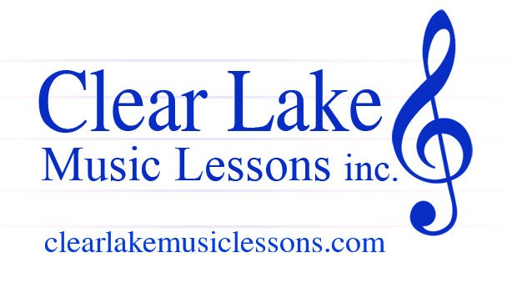


Michael Kobus Foundation
Clear Lake Music Lessons Scholarship Application

Date of Application: ______________________

Applicant’s Name: ______________________________
Age: ___________ Birth Date: ___________________

Mailing Address: _________________________________________________________
City: ________________ State: _____________ Zip: ______________
Applicant Resides with (circle one): Both Parents Mother Father Guardian

Name of Parent/Guardian: _________________________
Parent/Guardian Phone#: _____________________ Email: _______________________________
Employer: ___________________________ Occupation: _______________________________

Name of Parent/Guardian: _________________________
Parent/Guardian Phone#: _____________________ Email: _______________________________
Employer: ___________________________ Occupation: ________________________________

Applicant Information

Instrument of Interest: ____________________________
Do you own/rent this instrument? ________________________
Number of Years Student Has Played This Instrument? __________
School Attending: ___________________________________ Grade: ___________
Does your School have a Music Program? Yes _______ No _______
Do you Participate in Band/Chorus/Orchestra? Yes _______ No _______
(ALL INFORMATION IS STRICTLY CONFIDENTIAL)

Financial Information

Household Annual Gross Income $ _______________

Monthly expenses |  |  | Additional Monthly Income
Rent/Mortgage | $ |  | Unemployment | $
Childcare | $ |  | Social Security | $
Car Payment | $ |  | Worker’s Comp | $
Car Insurance | $ |  | Child support/alimony | $
Other: __________ | $
(Additional financial information may be requested)

Does Your Child Receive Free Lunch at School? Yes _________ No ________

Please tell us any additional information and/or circumstances you feel the scholarship committee should consider when evaluating your application:

I certify all the information included in this application is true and correct. If awarded a music scholarship we agree to participate in each scheduled lesson with CLML and understand if we do not fulfill this obligation, we will be asked to repay the scholarship funds awarded.

Parent/Guardian Signature: ___________________________ Date: ______________

